Burroughs, William S. (William Seward Burroughs II) (1914-1997)

Joshua Lam (SUNY-Buffalo)

Born in St. Louis, Missouri, William S. Burroughs was a major figure of the Beat Generation. He is known primarily for his controversial novel Naked Lunch (1959)—the subject of a U.S. obscenity trial—and for his use of the cut-up technique, developed by his friend, British- born artist Brion Gysin. The technique involves cutting up and reassembling text or film in random order to produce non-linear anti-narratives; influences include Dadaist collage procedures and T.S. Eliot’s ‘The Waste Land’. Using this technique, Burroughs collaborated with Gysin and filmmaker Anthony Balch to produce short experimental films, including Towers Open Fire (1963), The Cut Ups (1967), and Bill and Tony (1972). The films juxtapose and overlay documentary footage of Burroughs and others with stock footage, as well as surreal, pornographic, and science-fiction imagery. Burroughs also narrated portions of the films, in part using text appropriated from Scientology manuals and film scripts—notably Tod Browning’s Freaks (1932). Fragments from The Soft Machine (1961), part of the science-fiction Nova Trilogy, appear in the narration of Towers Open Fire. Burroughs also appeared in numerous feature films.

Select Filmography:

Many of these films were collaborations between Burroughs, Balch, and Gysin, among others. Burroughs contributed to writing, narration, and appeared in many of them. The list is necessarily partial.

Häxan (1922) (Swedish film directed by Benjamin Christensen; re-released by Balch in 1968 with the subtitle Witchcraft Through the Ages, with expanded narration by Burroughs)
Towers Open Fire (1963)
William Buys a Parrot (1963)
The Cut Ups (1967)
Bill and Tony (1972)
Ghosts at Number Nine (1982) (Consists of footage filmed by Balch between 1961-1965)
Naked Lunch (1991) (Feature film directed by David Cronenberg, adapted from Burroughs’s 1959 novel and biographical materials)
Ah Pook Is Here (1994) (Animated short directed by Phillip Hunt, written and narrated by Burroughs)

Select Bibliography:
Burroughs produced dozens of books, including novels, short fiction, non-fiction, and other collected materials. This list is necessarily partial.

Junkie (Ace, 1953)
Naked Lunch (Grove, 1959)
The Soft Machine (Olympia, 1961)
The Ticket that Exploded (Olympia, 1962)
Nova Express (Grove, 1964)
The Last Words of Dutch Schultz: A Fiction in the Form of a Film Script (Cape Goliard, 1970)
The Job: Interviews with William S. Burroughs (Conducted with Daniel Odier; Grove, 1970)
The Third Mind (Co-authored with Brion Gysin; Viking, 1978) (Includes cut-up texts and essays on the cut-up technique)

References and Further Reading:

Baldwin, D. (2000) ‘“Word Begets Image and Image is Virus”: Undermining Language and Film in the Works of William S. Burroughs’, College Literature 27 (1): 63-83.

Bridgett, R. (2003) ‘An Appraisal of the Films of William Burroughs, Brion Gysin, and Anthony Balch, in Terms of Recent Avant Garde Theory and History’, Bright Lights Film Journal 39. http://brightlightsfilm.com/39/cutups1.php

Burroughs, W. (1991) ‘Screenwriting and the Potentials of Cinema’, Writing in a Film Age: Essays by Contemporary Novelists, ed. Keith Cohen, Niwot: University of Press of Colorado.

McLuhan, M. (1964) ‘Notes on Burroughs’, Nation, 28 Dec. 1964: 517-19.

Murphy, Timothy S. (1998) Wising Up the Marks: The Amodern William Burroughs, Berkeley: University of California Press.

Sargeant, J. (1997) Naked Lens: Beat Cinema, London: Creation.

Schneiderman, D. and P. Walsh (eds.) (2004) Retaking the Universe: William S. Burroughs in the Age of Globalization, London: Pluto.

Skerl, J. and R. Lydenberg (eds.) (1991) William S. Burroughs at the Front: Critical Reception, 1959-1989, Carbondale: Southern Illinois University Press.

Paratextual Material:

1. Häxan: Witchcraft Through the Ages: http://www.youtube.com/watch?v=La1tzPS1R7Q
This film is also available on archive.org, which hosts uncopyrighted material. The link to the film through that site is here: https://archive.org/details/WitchcraftThroughTheAges-haxan-WilliamBurroughsNarration.

2. Virtually all of Burroughs’s films are available on YouTube:

Towers Open Fire: http://www.youtube.com/watch?v=SjB--bgcBa0
William Buys a Parrot: http://www.youtube.com/watch?v=ME-t5lZ5r9U
The Cut Ups: http://www.youtube.com/watch?v=n7_Y0NvLtH4
Bill and Tony: http://www.youtube.com/watch?v=zFrTAJUQKq4
Ghosts at Number Nine: http://www.youtube.com/watch?v=bmeeNFRn7ys

3. Audio Clip:

Burroughs reads from Nova Express in 1974: The entire reading (by John Giorno and Burroughs) is available via creative commons. Burroughs begins at 40:50, and that particular section ends at 43:52. That short clip would be best. https://archive.org/details/AM_1974_11_07_c1

5. Screen Grabs

From Towers Open Fire:
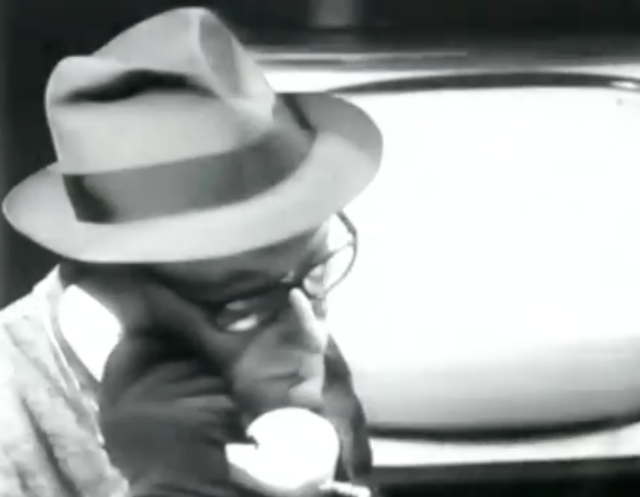
From Ghosts at Number Nine:
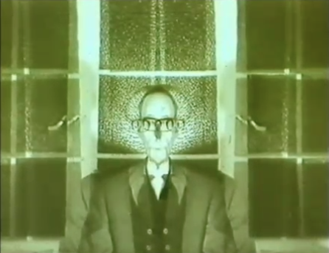

From The Cut-Ups (2 different images): 